1 i) Newton’s second law: An object which experiences an external force will accelerate in that same direction (which could also be just a change in direction, ie: turning).

ii) Newton’s third law: For every action there is an equal and opposite reaction so the water being forced out one end pushes the hose back the other way.

iii) Newton’s third law. The elastic band puts a force on the papers as it tries to contract but the paper places an equal but opposite reactive force which keeps the elastic band in place.

2. Missing

3. i)

3 ii)

3 iii) Has not taken into account friction and air resistance

4.

5. Work for 1 lift:

$$W=Fs=mgs=10*9.8*1.3=127.4J$$

Work for 6 lifts = 127.4 \* 6 = 764.4J

6.

7. Missing

8.

9.

10.

11. Missing

12. The final potential energy must be the same. The kinetic energy of the faster conveyer must be more (as kinetic energy proportional to velocity squared). The work is the same (if looking at it from the perspective of the change in potential energy). The power is more for the faster conveyer (same energy in less time).

13. The potential energy at the top of the motion:

$E_{P}=mgh=1.7*9.8*20=333J$

As the basketball falls, it loses potential energy as h is decreasing. This energy is converted into kinetic energy as the ball increases in velocity.

The velocity at the bottom:

$$v=u+at=0+9.8*1.8=17.6ms^{-1}$$

The kinetic energy at the bottom:

$$E_{K}=\frac{1}{2}mv^{2}= 0.5*1.7*{17.6}^{2}=264J$$

The measured kinetic energy (from calculating the velocity is less than the theoretical amount due to the loss from air resistance. The measured and theoretical values would be the same on the moon (or any vacuum).

14 i). Ohm’s law. V=IR. It means that the voltage across a resistor is proportional to the current travelling through the resistor.

ii) From the graph, the line of best fit has a gradient of approximately 1.7

$R= \frac{1}{gradient}= \frac{1}{1.7}=0.6Ω$

iii)

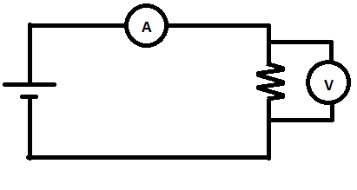

15.

16.

17.

18. Circuit A has an ammeter, 2 globes, a switch and battery in series with 3 globes in parallel.

Circuit B has a voltmeter, switch, 3 globes and a battery is series with a pair of globes in parallel.

19. The voltmeter in circuit B is in series. To measure voltage a voltmeter should be in parallel the globe to be measured.